UiPath enhancements <month>

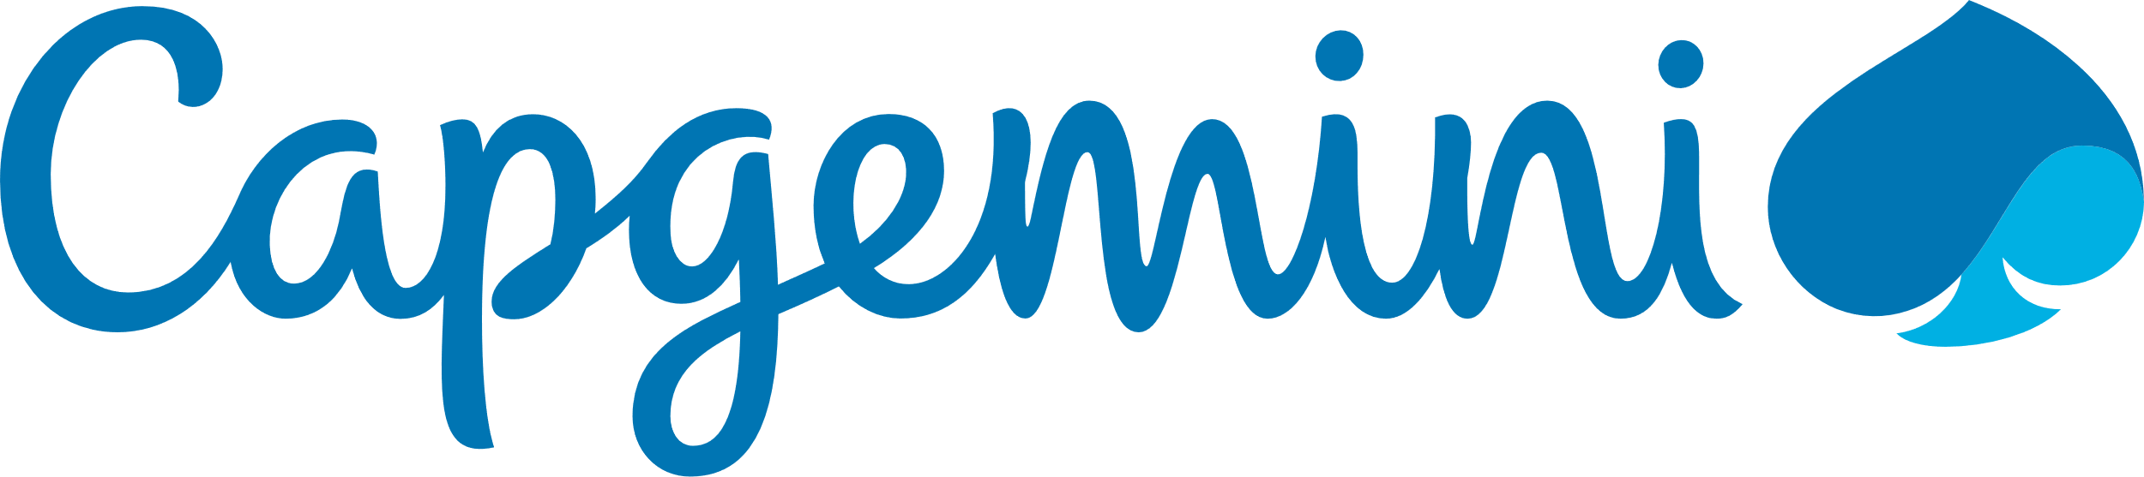

Contents

5. General 2

5.1 Documentation No notes about the documentation, but left ’5.1 Documentation’ in this document as it was part of the template. 2

5.2 Version control Gimmi gimmi git 2

# General

## Documentation

No notes about the documentation, but I left ’5.1 Documentation’ in this document as it was part of the template.

## Version control

### GIT integration

I assume that UiPath already know how much the community that are using their tool is craving GIT integration. There have been several posts about this in the UiCommunity, with representatives from UiPath confirming that they are considering it. My colleagues and I have been discussing this subject, and we all agree that GIT integration for UiPath would be a valuable asset when using the tool, and should be a high priority for UiPath. It would make working with UiPath substantially better.

### Merging conflict

Even though UiPath does not have GIT integration, a lot of us developers are still using GIT as a form of “version control”. This is not optimal since two developers are unable to do changes on the same file, before merging their changes. Solving merge conflicts does not work on xaml files. The resulting file gets corrupted and will not run. This issue is something we were hoping you could work on. By fixing merge conflict for xaml files, us developers would be able to use GIT efficiently. But ultimately, the best thing would be for UiPath to have GIT integration.

About Capgemini

With more than 190,000 people, Capgemini is present in over 40 countries and celebrates its 50th Anniversary year in 2017. A global leader in consulting, technology and outsourcing services, the Group reported 2016 global revenues of EUR 12.5 billion. Together with its clients, Capgemini creates and delivers business, technology and digital solutions that fit their needs, enabling them to achieve innovation and competitiveness. A deeply multicultural organization, Capgemini has developed its own way of working, [the Collaborative Business Experience™](http://www.capgemini.com/about/how-we-work/the-collaborative-business-experiencetm), and draws on [Rightshore®](http://www.capgemini.com/about/how-we-work/rightshorer), its worldwide delivery model.

Learn more about us at www.capgemini.com.



This message is intended only for the person to whom it is addressed. If you are not the intended recipient, you are not authorized to read, print, retain, copy, disseminate, distribute, or use this message or any part thereof. If you receive this message in error, please notify the sender immediately and delete all copies of this message.

This message contains information that may be privileged or confidential and is the property of the Capgemini Group.  
Copyright © 2017 Capgemini. All rights reserved.

Rightshore® is a trademark belonging to Capgemini.